Happiness – Building Knowledge and Exploring Ideas
(Source) Where in Britain would you be happiest?
http://www.bbc.co.uk/guides/z3g487h
Where you live may affect your happiness | - People in different locations have distinct personality traits  - Our happiness may be influenced by how well me match with the people around us

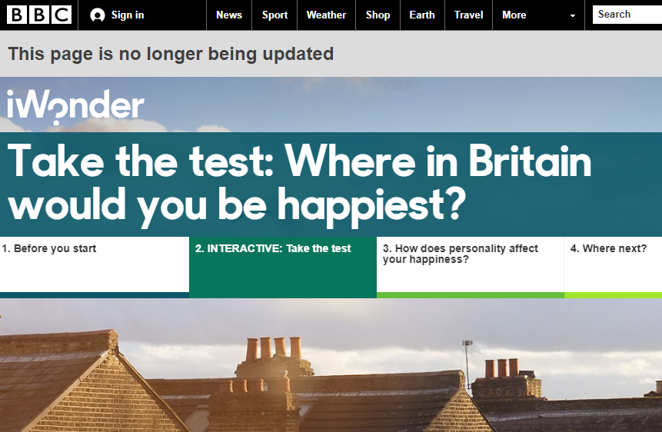

(Source) Psychology Today - Happiness
https://www.psychologytoday.com/basics/happiness
Intro/general info | - “More than simply positive mood, happiness is a state of well-being that encompasses living a good life—that is, with a sense of meaning and deep satisfaction.”  - Achieving happiness involves times of discomfort or unhappiness  - Money – brings freedom from worry, but not necessarily happiness  - Genetic make-up is influential  - Social relationships also important  - We have personal control over our ability to be happy – doing what you like to do an a regular basis, undertake challenges, set goals, work on friendships and find a purpose for your life all important

(Source) Psychology Today – What happy people do differently
https://www.psychologytoday.com/articles/201307/what-happy-people-do-differently
Discomfort/risk taking produces happier people | - Linked to many benefits – higher wages, better immune system, better creativity  - Emotional and personal – everyone has their own set-point when it comes to their feelings, determined by genetics and experience  - Positive events lift you up, then you return to your set-point  - Also important is your attitude – when do you decide things are good or bad  - This involves a combination of your expectations, your ideals, your acknowledgement of what you cannot change and more  - So h can be intentional and strategic  - Role of everyday habits and choices  - “It turns out that activities that lead us to feel uncertainty, discomfort, and even a dash of guilt are associated with some of the most memorable and enjoyable experiences of people's lives. Happy people, it seems, engage in a wide range of counterintuitive habits that seem, well, downright unhappy.”  - Taking risks and pushing your growth, being adventurous does much to bring sustained happiness  - Happy people are proven to be curious  - “curious people invest in activities that cause them discomfort as a springboard to higher psychological peaks.”  - Happy people recognize there are benefits to experiencing the “novel. Complicated, uncertain or even upsetting.”  - Happy people less likely to be less analytical or detail-oriented (depressed people more likely to think about their experiences – emotional price)  - They are less skeptical  - “The happiest people have a natural emotional protection against getting sucked in by the intense gravitational pull of little details.”  - Happiest people celebrate the successes of their friends – make a big deal over the success of their friends and family

(Source) Psychology Today – Beyond happiness: the upside of feeling down
https://www.psychologytoday.com/articles/201501/beyond-happiness-the-upside-feeling-down
Emotion serves a purpose | - Emotions are not inherently negative or positive  - Every emotional response has an important job to do – “whether it's preparing us to move toward what we want (anger), urging us to improve our standing (envy), or allowing us to undo a social gaffe (embarrassment).”  - They are meant to help us achieve our goals! – direct us as to where we should go – identify trouble, opportunity – instruments of survival

(Source) Japanese Psychological Research - "The Happiness of Individuals and the Collective."
Uchida, Yukiko and Shigehiro Oishi. "The Happiness of Individuals and the Collective." Japanese Psychological Research, vol. 58, no. 1, Jan. 2016, pp. 125-141. EBSCOhost, doi:10.1111/jpr.12103.
Individual vs societal happiness | - Collective vs individual happiness – how to measure happiness  - Role of culture  - Importance of studying the happiness of collectives

Cameron 2018

Creating a Research Proposal – Graphic Organizer
Idea:
-individual happiness is separate from collective happiness
-value in studying collective happiness
Idea:
-Emotions - They are meant to help us achieve our goals! – direct us as to where we should go – identify trouble, opportunity – instruments of survival
Idea:
-“It turns out that activities that lead us to feel uncertainty, discomfort, and even a dash of guilt are associated with some of the most memorable and enjoyable experiences of people's lives. Happy people, it seems, engage in a wide range of counterintuitive habits that seem, well, downright unhappy.”

Idea:
-We have personal control over our ability to be happy – doing what you like to do an a regular basis, undertake challenges, set goals, work on friendships and find a purpose for your life all important
Idea:
-People in different locations have distinct personality traits
-Our happiness may be influenced by how well me match with the people around us

Sophocles said, “There is no success without hardship.” To what extent are we meant to experience adversity?
Considering time, resources and my goals, I choose…
New idea:
I consider myself to be a “happy” person. What do I know about myself that contributes to this with respect to trying new things?
New idea:
Is life meant to be difficult? Is it inevitable?
New idea:
If we know what will bring happiness, what can we do as individuals to get there? How might this be different for each of us?
Which ideas are of most interest to me:
Taking risks, putting ourselves in uncomfortable situations and disappointments will contribute greatly, surprisingly, to our personal happiness.

