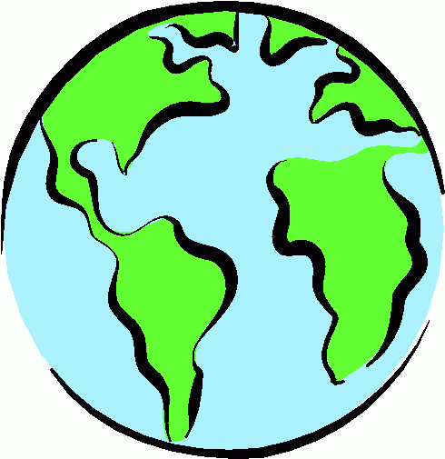
Humanities Civilizations Inquiry Project

With this project you are going to get the opportunity to research and explore an ancient civilization.
Think about our discussion, and the paragraph that you wrote: what is the most essential element to a civilization?

That is your starting place.

You are responsible for picking ONE area of humanity and exploring the effect of that particular element on the civilization of your choice.
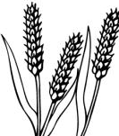
Thinking…
How did it contribute to the success or the continued existence of this society?
Did it contribute to the expansion of an empire?
How did it affect peoples’ day to day lives?
Did it make their society better? Help them progress?

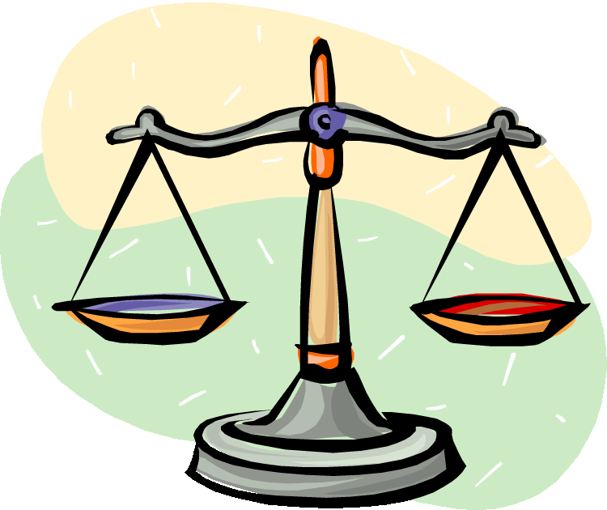

We will be spending the next week in the library learning about…
- Research skills
- Note taking
- Reliable sources of information
- Good work and research habits
- Learning about the inquiry process and ourselves as learners

You are expected to reflect on the process throughout the week (you will be given a journal in which to do this) and demonstrate your learning and conclusions in a format of your choosing.

You will be assessed in two different ways. The majority of your mark will be about the process – both in the understanding and execution of the inquiry process.
So you will be MARKED… on THIS!

The other part of your mark will be about how well you are able to represent what you have learned about your chosen civilization AND how you have used that information to answer your inquiry question.

Civilizations
Africa | Asia | Europe | Americas
Ancient Egypt (Egypt)  Ancient Ethiopia (D’mt) (Ethiopia)  Ancient Somalia (Punt) (Somalia)  Kush (Ethiopia)  Axum (Ethiopia)  Nok (Nigeria)  Igbo-Ukwu (Nigeria)  Wagadou (Ghana)  Mali Empire (West Africa)  Songhai Empire (West Africa)  Ashanti Empire (Ghana)  Abyssinia (Ethiopia)  Benin Empire (Nigeria)  Oyo Empire (Nigeria)  Dahomey (Benin)  San (Botswana, Namibia, South Africa, Angola, Zimbabwe)  Khoikhoi (South Africa) | Hayasa-Azzi (Armenia)  Mesopotamia (Assyria) (Syria, Iraq, Iran)  Indus Valley civilization (South Asia)  Persia (Iran)  Vedic India (India)  Caliphate (Saudi Arabia)  Ottoman Empire (Turkey)  Han China (China)  Goryeo Korea (Korea)  Mongol Empire (Central Asia)  Ming China (China)  Confucian Vietnam (Vietnam)  Anghor Cambodia (Cambodia)  Dvaravati, Hariphunchai, Sukhothai, Ayutthaya Kingdom (Thailand)  Pagan Burma (Burma)  Philippine Classical Period (Phillipines) | Minoan Civilization (Crete)  Mycenaean Greece (Greece)  Nuragic Civilization (Sardinia)  Huns (Eastern Europe, Central Asia)  Celts (Central & Northern Europe)  Nairi (Armenia)  Urartu (Turkey)  Ancient Phoenicia (Syria, Lebannon, Northern Israel)  Ancient Greece (Greece)  Ancient Carthage (Northern Africa/Mediterranean)  Ancient Rome (Western Europe, Northern Africa)  Etruscans (Italy, Corsica)  Illyrians (Balkans)  Iberians (Spain and Portugal) | Norte Chico (Peru)  Zapotec civilization (Mexico)  Ancient Pueblo peoples (SW US)  Caddoan Mississipian culture (Oklahoma, Arkansas, Texas, Louisiana)  Fort Ancient (Ohio River)  Hohokam (Arizona)  Mogollon culture (New Mexico, Arizona, Texas)  Oneota (Minnesota)  Patayan (Central & Eastern Arizona)  Tlaxcala (Mexico)  Toltec (Mexico)  Aztec civilization (Mexico)  Maya civilization (Mexico, Guatemala, Belize, Honduras, El Salvador)  Purepecha (Mexico)  Tlapanec people (Mexico)  K’iche’ Kingdom of Q’umarkaj (Guatemala)  Chimor (Peru)  Inca Empire (Peru, Bolivia, Ecuador, Colombia)  Aymara (Bolivia, Peru, Chile)  Muisca Confederation (Colombia)  Haida (British Columbia)  Mik’maq (Ontario, Newfoundland)  Iroquois (Quebec)  Algonquin (Ontario)  Huron (Ontario)  Blackfoot (Alberta)  Cree (Alberta)  Salish (British Columbia)  Nootka (British Columbia)

